201533661 이승수’s lab6

<lab1>

#include <stdio.h>

#include <stdlib.h>

#pragma warning(disable:4996)

#define SIZE 20

struct person

{

char name[10];

int age;

char hobby[10];

};

void main()

{

struct person* People;//선언할때 구조체를 어레이로만들면 People이름으로 포인터위치를 여러개 만들어주는 의미

FILE *inF, *outF;

int j = 10, i = 0;

People = (struct person*)malloc(sizeof(struct person) * 20);//여기서 크기를 키워줘야 어레이를 잡아주는 의미가 있다.

inF = fopen("personal.txt", "r");//

while (!feof(inF))

{

fscanf(inF, "%s %d %s", People[i].name, &People[i].age, People[i].hobby);

i++;

}

fclose(inF);

outF = fopen("output.txt","w");

for (j = 10; j < 50; j += 10)

{

fprintf(outF,"\nage from %d to %d", j, j + 9);

fprintf(outF,"\n-----------------------------");

for (i = 0; i < 20; i++)

{

if (j <= People[i].age && People[i].age < (j + 9))

{

fprintf(outF,"\n%s %d %s", People[i].name, People[i].age, People[i].hobby);

}

}

}

fclose(outF);

getchar();

}



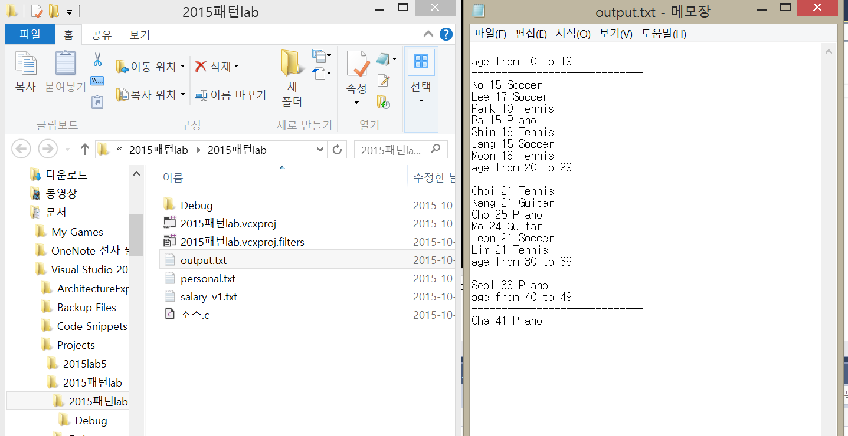

<lab2>

#include <stdio.h>

#include <stdlib.h>

#pragma warning(disable:4996)

#define SIZE 20

struct person

{

char name[10];

int age;

char hobby[10];

};

void main()

{

struct person* People;

FILE *inF, *outF;

int j = 10, i = 0;

People = (struct person*)malloc(sizeof(struct person) * 20);

inF=fopen("personal.txt", "r");

while (!feof(inF))

{

fscanf(inF, "%s %d %s", People[i].name, &People[i].age, People[i].hobby);

i++;

}

fclose(inF);

outF = fopen("age.txt", "w");

for (i = 0; i < 20; i++)

{

fprintf(outF, "\n%s %d", People[i].name, People[i].age);

}

fclose(outF);

outF = fopen("hobby.txt", "w");

for (i = 0; i < 20; i++)

{

fprintf(outF, "\n%s %s", People[i].name, People[i].hobby);

}

fclose(outF);

}

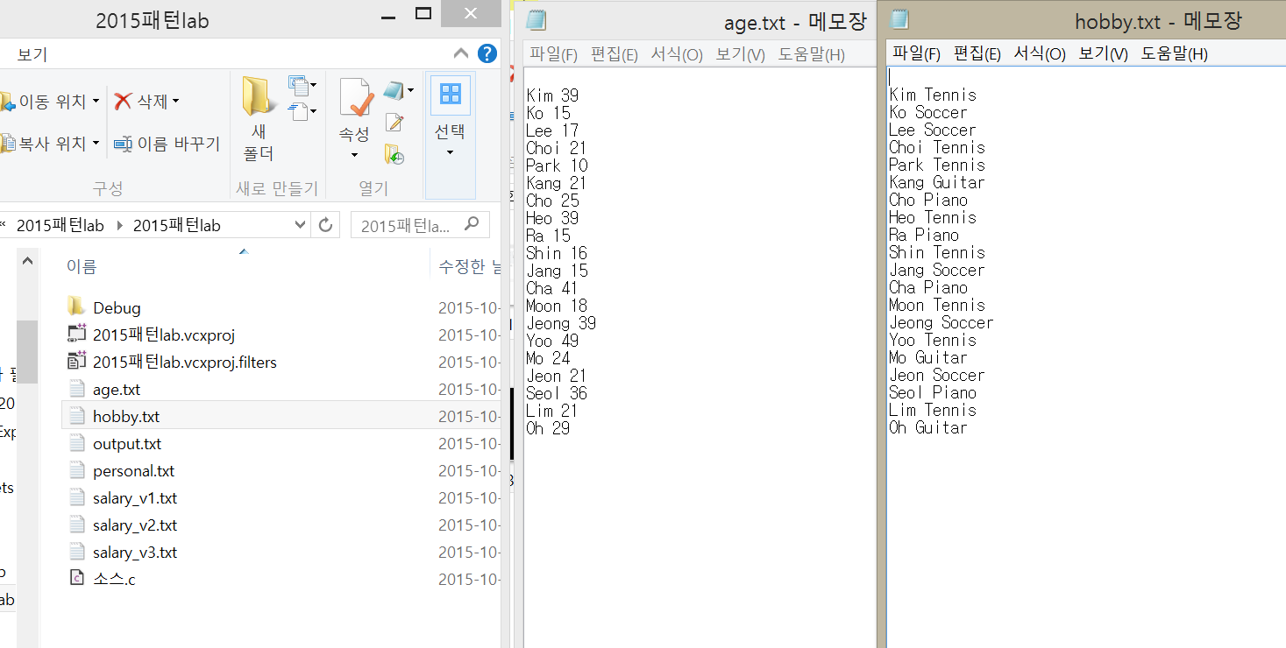

<lab3>

#include <stdio.h>

#include <stdlib.h>

#pragma warning(disable:4996)

#define SIZE 20

struct person{

char name[20];

int age;

float salary;

};

void Versioning(struct person Ver[], int A, float j)

{

int i;

for (i = 0; i < SIZE; i++)

{

if (A <= Ver[i].age && Ver[i].age < (A + 9))

{

Ver[i].salary *= j;

}

}

}

void main()

{

struct person Ver_1[20], Ver_2[20] = { NULL };//선언할때 구조체를 어레이로만들면 여기저기 생겨서

FILE *inF, *outF;

int A, i = 0;

float j;

inF=fopen("salary_v1.txt", "r");

for (i = 0; i < 20; i++)

{

fscanf(inF, "%s %d %f", Ver_1[i].name, &Ver_1[i].age, &Ver_1[i].salary);

}

fclose(inF);

for (i = 0; i < SIZE; i++)

{

Ver_2[i] = Ver_1[i];

}

Versioning(Ver_2, 40, 1.1);

outF = fopen("salary_v2.txt", "w");

for (i = 0; i < SIZE; i++)

{

fprintf(outF, "\n%s %d %f ->", Ver_1[i].name, Ver_1[i].age, Ver_1[i].salary);

fprintf(outF, " %s %d %f", Ver_2[i].name, Ver_2[i].age, Ver_2[i].salary);

}

fclose(outF);

inF = fopen("salary_v2.txt", "r");

while (!feof(inF))

{

fscanf(inF, "%s %d %f", Ver_2[i].name, &Ver_2[i].age, &Ver_2[i].salary);

}

fclose(inF);

Versioning(Ver_2, 30, 1.2);

outF = fopen("salary_v3.txt", "w");

for (i = 0; i < SIZE; i++)

{

fprintf(outF, "\n%s %d %f ->", Ver_1[i].name, Ver_1[i].age, Ver_1[i].salary);

fprintf(outF, " %s %d %f", Ver_2[i].name, &Ver_2[i].age, &Ver_2[i].salary);

}

fclose(outF);

}



